Scholarship Request Form

Please fill out this form if you wish to apply for a scholarship towards a 4-H opportunity that the Leaders Association does not currently offer a scholarship.
- Examples: Badger Dairy Camp, Arts camps, and the State 4-H teams (excludes 4-H summer camp)
- Does not include county sponsored events. See executive board for clarification and approval.
- Does not include educational travel opportunities. List not limited to: Explore WI, American Spirit, Space Camps, Citizenship Washington Focus (CWF), WI 4-H & Youth Conference, National 4-H Congress, and National 4-H Conference.
- To be eligible for consideration, you must be a member in good standing in Outagamie County 4-H.
- You may request up to half of the program fees (registration).
- Scholarships will be based upon funds available within the 4-H Leaders Association budget.
- All requests should be made within one month of the opportunity
- This form can also be used by leaders requesting funding for educational opportunities or chaperone registrations.

Name of Person Filling out Form Phone #
Member’s Name
4-H Club
Check made payable to
Address
Parent or Legal Guardian
4-H Opportunity
Date of event Location
Total Registration cost that you paid
If you received or will receive additional funding, what was amount received or that will be received?
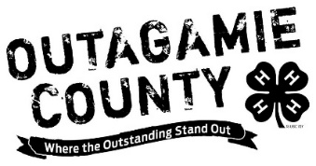
Submit Request Form with proof of attendance (agenda signed by organizer, certificate of participation, etc.) to:

Outagamie County UW-Extension Office
ATTN: 4-H Leaders Association
3365 W. Brewster Street
Appleton, WI 54914

For Office Use only:

Date Received: __________________
Check # ____________________Date _____________

