Outagamie County 4-H
Cloverbud Record Book
4-H
Cloverbuds

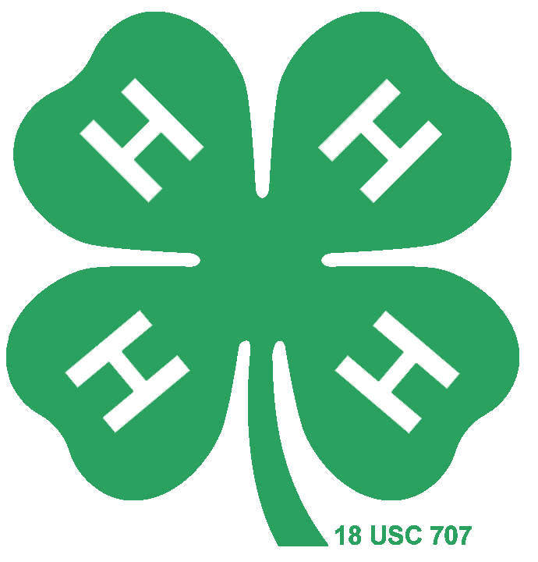

Member Name: __________________
Club: _________________________
My name is ____________________________.
I am ____________ years old.
I am in the ____________ grade.
There are ___________ people in my family.
I have ____ brothers and _____ sisters.
I live ____ in a city or village
____ in a home in the country
____ on a farm in the country
Here is a picture of me!
My 4-H Club
A 4-H club is a group that meets to learn about 4-H, works together and has fun. The 4-H club as adult leaders who tell me about events and activities happening in 4-H.

My club name is ________________________.
My club meets on ______________ (day of the week) at _________ (time) at ___________________ (location).
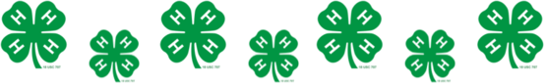

My Club Officers are
President _____________________________
Vice President _________________________
Secretary ____________________________
Treasurer ____________________________
Reporter _____________________________
Recreation ____________________________
Sergeant-at-Arms ______________________
My club leader is _______________________.
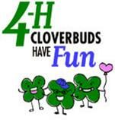
My cloverbud leader is ___________________.

Cloverbud Activity Record
Fun Club Activities I did this year:
____________________________Date: ______
____________________________Date: ______
____________________________Date: ______
____________________________Date: ______
____________________________Date: ______
____________________________Date: ______
____________________________Date: ______
____________________________Date: ______
____________________________Date: ______
____________________________Date: ______
____________________________Date: ______
____________________________Date: ______
Fun County Activities I did this year:
____________________________Date: ______
____________________________Date: ______
____________________________Date: ______
____________________________Date: ______
____________________________Date: ______
____________________________Date: ______

CL verbuds

I did a demonstration on _____________________________________
_____________________________________
at the ___________________ club meeting.

The 4-H Pledge

I pledge my _____________to clearer thinking, my ________________ to greater loyalty,
my _________________ to larger service,
my __________________ to better living, for my __________________, my community, my _______________________, and my world.

4-H Motto:
“To Make the Best Better”

4-H slogan:
“Learn by Doing”

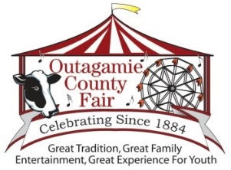
Come to the Fair
The Outagamie County Fair was _______________________________ (date).
I entered these projects:
- ____________________________
- ____________________________
- ____________________________
Add a picture of yourself with your fair project.

My Cloverbud Story
My name is _____________________. This is my ______ year in Cloverbuds. I went to ____ regular 4-H club meetings.
This year, I have done club activities like __________________________________ and ____________________________________.
This year, my favorite thing to do at 4-H was _________________________________________________________________________. I liked it because _______________________
____________________________________. My favorite project I showed at the fair was ____________________________________.
When I was working on my project, the hardest thing was _____________________________
____________________________________. When I worked on my projects I learned _________________________________________________________________________. I like 4-H because _____________________________________
____________________________________.
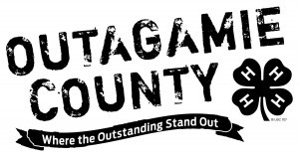
Please feel free to add more pictures.

Parent’s Signature Date
S:\UWX\4HINFO\Enrollment\Cloverbud-record-book.docx

