**Outagamie Forage Council and Midwest Forage Association**

**2024 Annual Meeting & Educational Program**

**Buzz’s Pub/Grill – W2116 County Rd S, Freedom, WI 54130**

**Thursday, February 8, 2024**

**9:30 a.m. Registration 10:00 a.m. Meeting**

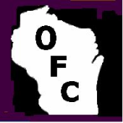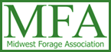

**9:30 A.M.** **Registration**

**10:00 A.M.** **Welcome – Matt Van Wychen, President, OFC and Kevin Jarek, Advisor**

**10:15 A.M.** **Got Soil Moisture? What You Need to Know Ahead of the 2024-Planting Season**

*Francisco Arriaga, UW-Madison, Soil Science*

**11:05 A.M.** **What Have We Learned from the Statewide UW Winter Cereal Forages Project? Research Project Roundup-Results & Updates on Ongoing & New Efforts for 2024**

*Kevin Jarek, Crops & Soils, UW-Madison, Div. of Extension, Outagamie & Winnebago*

**11:50 A.M.** **Lunch and Outagamie Forage Council Youth Scholarship Presentation**

**12:40 P.M. The 2023 Drought's Impact on Corn Silage Yield & Feeding Quality - What You Should Know and How to Plan/Adjust for 2024**

*Stu Rymph, PhD, CCA, PAS, Tech Support Dairy Nutritionist, Purina Animal Nutrition LLC*

**1:30 P.M. Midwest Forage Association 2024 Program Update**

*Chelsea Russell, Local Council Director, Midwest Forage Association*

**1:45 P.M.** **Annual Business Meeting** – *Matt Van Wychen, President, Outagamie Forage Council*

**2:00 P.M.** **Auction Fundraiser with Refreshments…**

**3:30 P.M**. **Directors’ Reorganization Meeting**

*2024 Outagamie County Forage Council Executive Board*

# C:\Documents and Settings\VanderDM\Local Settings\Temporary Internet Files\Content.IE5\8ZC5LR0I\MCj02909290000[1].wmf- - - - - - - - - - - - - - - - - - - - - - - - - - - - - - - - - - - - - - - - - - - - - - - - - - - - - - - - - - - - - - - - - -

# 2024 Outagamie County Forage Council Registration Form

***Please fill out a separate form for each person (may combine payment on one check)***

Name:_____________________________________________________ Phone Number:__________________________

Address:_____________________________________City:________________________________ Zip:_____________

Business/Organization __________________________________ E-mail _______________________________________

#### Registration & Membership Payment Choices-Please Read Carefully

____Midwest Forage Association & Outagamie Forage Council Membership & Lunch @ $75.00=$______

____Outagamie Forage Council Membership & Lunch @ $45.00=$______

____Midwest Forage Association & Outagamie Forage Council Membership (Not Attending) @ $55.00=$______

____Outagamie Forage Council Membership (Not Attending) @ $25.00=$______

____MFA members who renewed in December ($55 already paid to MFA) only need to buy lunch @ $20.00=$______

**TOTAL AMOUNT ENCLOSED $______**

# CHECK PAYABLE TO: OUTAGAMIE FORAGE COUNCIL

**PLEASE RETURN BY: MONDAY, FEB. 5, 2024 TO: UW-Extension – Forage Council**

**3365 W Brewster Street**

**Appleton, WI 54914**

S:\UWX\AGRICULTURE\Ag Support Staff\FORAGE\Annual Mtg\2024\FC Annual Meeting 2024 agenda_registration form.docx

Greetings Outagamie Forage Council Members, Friends, and Supporters,…

I hope this correspondence finds you well and in good spirits as we begin 2024. 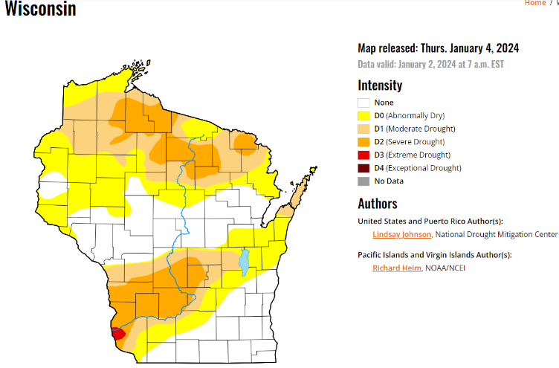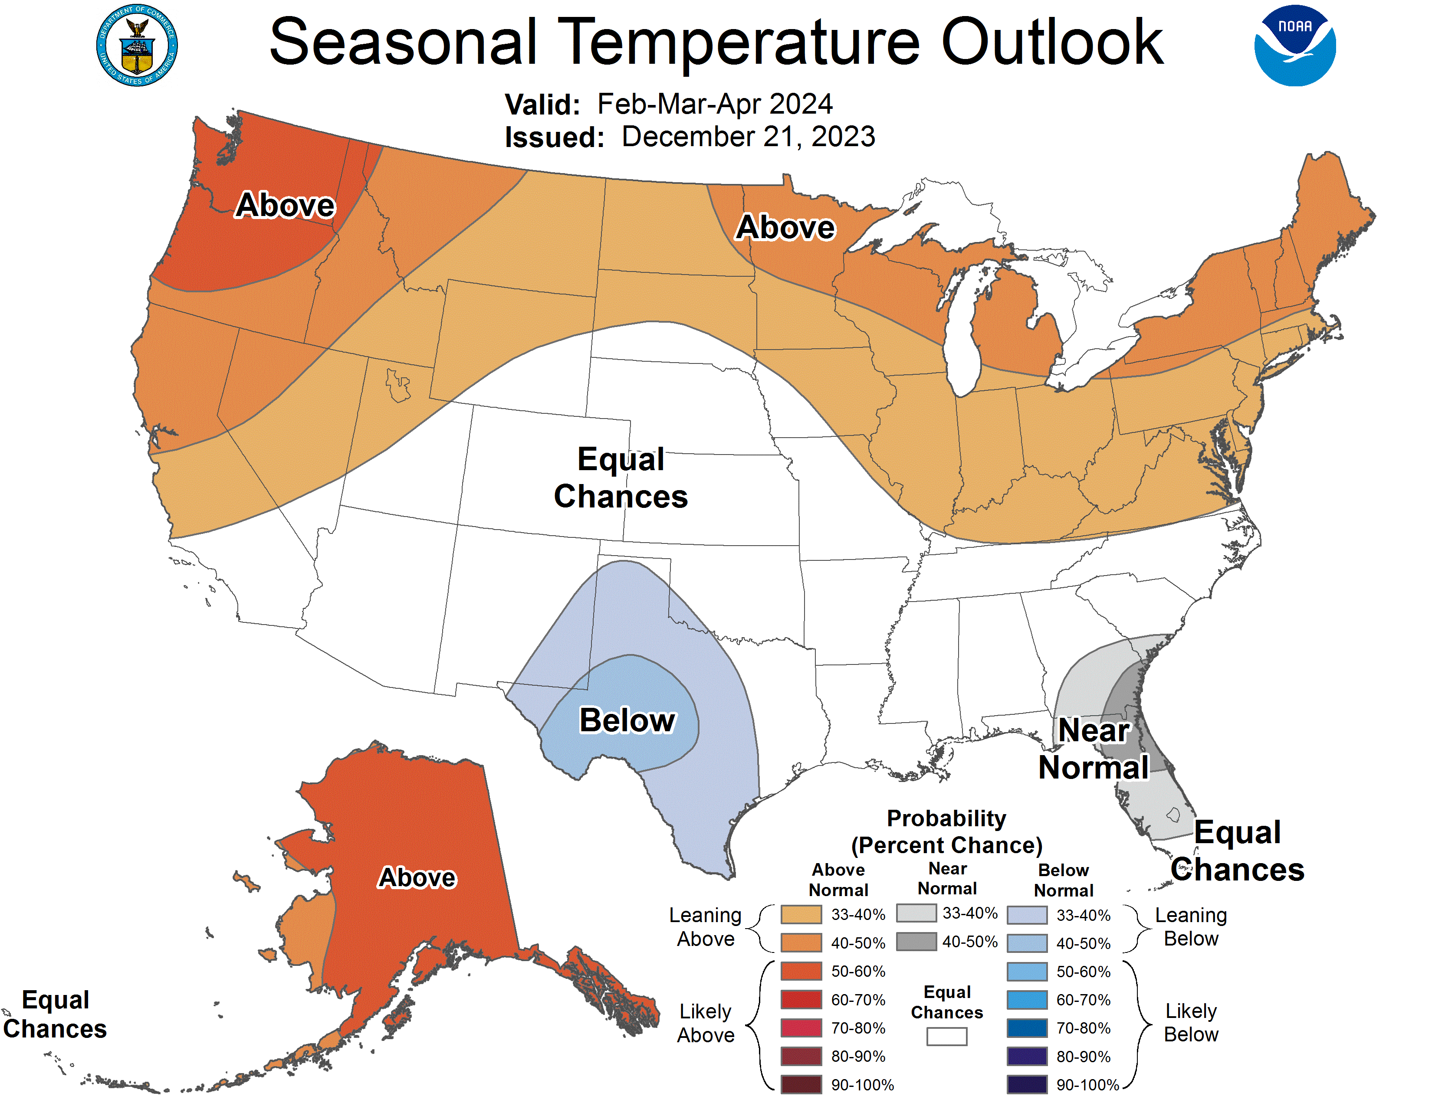Let us start with the elephant in the room... everyone experienced some level of drought conditions during the 2023 growing season. Our alfalfa stands impressed all season long proving to be extremely resilient given the very limited precipitation received for months on end. If anyone ever doubted the ability of an alfalfa taproot to mine subsoil moisture, those plants really came through when needed most. This fall, anyone who did any field tiling knows that subsoil moisture levels remain EXTREMELY Low/Dry. Even the 4”-6” of precipitation received this fall did not come close to replenishing what was lost. Individuals who have dug foundations for buildings are reporting after the first 12”-15”, there is little to no moisture to be found. Francisco Arriaga, UW-Madison, Soil Science, will be one of our featured speakers and he will discuss how the 2023 growing season affected our soils and what farmers and agricultural professionals should be focusing on as the 2024 planting season approaches. What do we need to know before we head to the fields to ensure a successful 2024 crop given our current and ongoing droughty conditions?

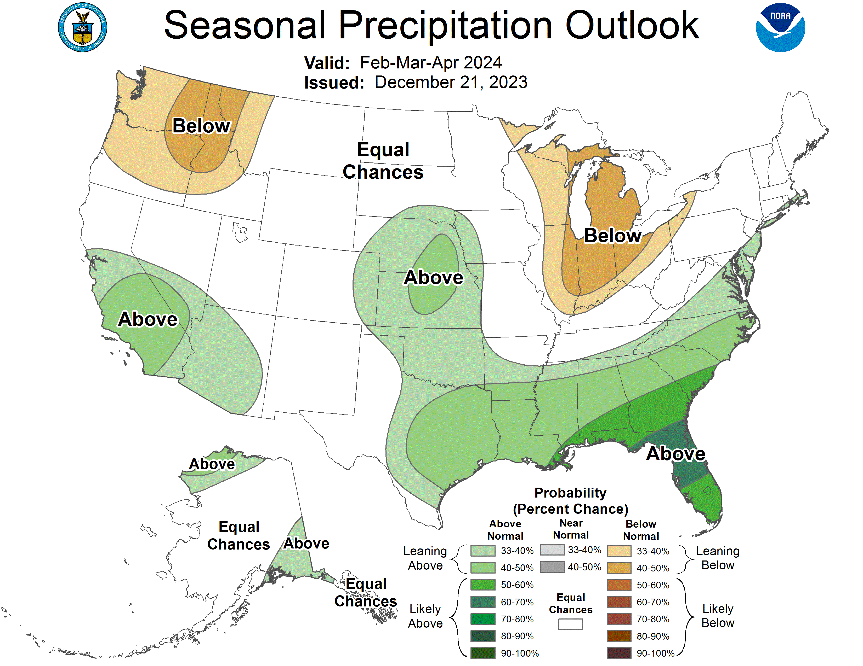Stu Rymph, PhD, CCA, PAS, Tech Support Dairy Nutritionist, Purina Animal Nutrition LLC will review his observations as it relates to the quality and feeding characteristics of our harvested 2023 forage crops. While corn silage is king, Stu will share what farmers are seeing across the spectrum of forages being fed/utilized right now. Stu’s dual background includes strong roots in agronomy allowing him to assess the nutritional/quality value of what was harvested. He also possesses the ability to discern how field conditions during the 2023 growing season ultimately impacted what our dairy herds will be feeding for the next several months and what we probably should be focusing on if we are dealt similar cards during the 2024 growing season.

This past year, the Outagamie Forage Council continued as the only Forage Council in the state to track and report height, maturity, and quality data for winter cereal forages. Winter cereal forages continue to increase in acreage here in northeast/east-central Wisconsin. Maximizing yield and quality requires not only timely planting and fertility, but most importantly, harvest management. Kevin Jarek, Regional Crops & Soils Educator, will share information related from an ongoing effort to evaluate Winter Cereal Forages Nitrogen (N) needs and share 2023 data on how forage quality & economics are affected by harvest timing.

As has been the case every year, we will recognize our Forage Council Youth Scholarship winner, get an update from Chelsea Russell, Local Council Director, Midwest Forage Association (MFA), conduct our Annual Business Meeting, and conclude with the auction fundraiser that helps support the many on-farm activities and educational outreach programs the Outagamie Forage Council conducts on an annual basis. ***All of us know more than some of us… plan to attend now!***

**Looking forward to seeing you all on Thursday, February 8, 2024 at Buzz’s Pub/Grill in Freedom!!!!!!!!!!!!**

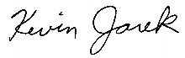Kevin Jarek - Advisor, Outagamie Forage Council