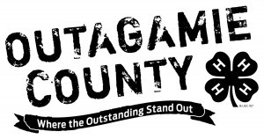Outagamie County 4-H

Member Activity Record

20Choose an item. - 20Choose an item.

Name Click or tap here to enter text. Grade Click or tap here to enter text.

Club Click or tap here to enter text. Years in 4-H including this year Click or tap here to enter text.

Number of meetings held by my club this year Click or tap here to enter text.

Number of meetings I attended Click or tap here to enter text.

*List only activities participated in by* ***YOU*** *this year. Examples: community service, demonstration, recreation,*

*Sunflower & Pumpkin Contest, educational experiences, camp, Family Learning Day, Dairy Bar, Action Center Stage, etc.*

*You are highly encouraged to add picture pages with captions to document your activities.*

Click or tap here to enter text.

Please list offices held, committee participation, educational experiences attended, etc.

Click or tap here to enter text.

______________________________________________ ______________________________________________

Member’s Signature Main Leader’s Signature